FOINNC
Jinan FOINNC Intelligent Technology Co., Ltd.

Network Configuration Instructions
M3xx Series

Flexible Open Interconnection

Table of Contents
1. Test Checklist 3
2. Hardware Connections 4
3. Setup Steps (Accessing the Computer from M350) 5
4. Appendix 11
4.1 Update History 11

This manual is copyrighted by Jinan FOINNC Intelligent Technology Co., Ltd. Without the company's written permission, no one may reproduce, copy, or translate this manual or any materials contained herein into other languages.
Due to the inherent lag in printed materials, some updates to the product may not be entered in a timely manner. We apologize for any inconvenience this may cause and appreciate your understanding.

- Test Checklist
The test checklist is as follows:
Name | Instructions | Quantities
M350 Four-Axis System V2 Version | Software Version: 2024-09-10-01  Firmware Version: 2021-1213-30 | 1
Laptop | Example: Windows 11 system, equipped with network interface | 1
Ethernet Cable | Use twisted pair cable, Category 5e or higher | 2
24V DC Power Supply | Rated current > 2A | 1
Wires | Power connection cable | Several
Router (optional) | Connected via router | 1

- Hardware Connections
The connection diagram is shown below:
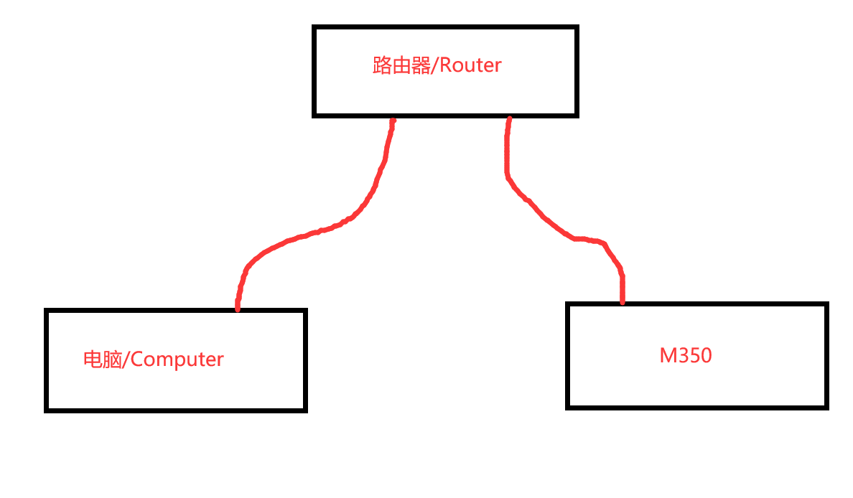
Connect the computer, router, and M350 using the network cable as shown in the diagram above.

- Setup Steps (Accessing the Computer from M350)
- Set the M350 parameters: Pr0284 Network boot Mode: auto-IP.
- Restart the system
- Check the IP address automatically assigned by M350; the method is as follows:
Enter the system management interface as shown below: 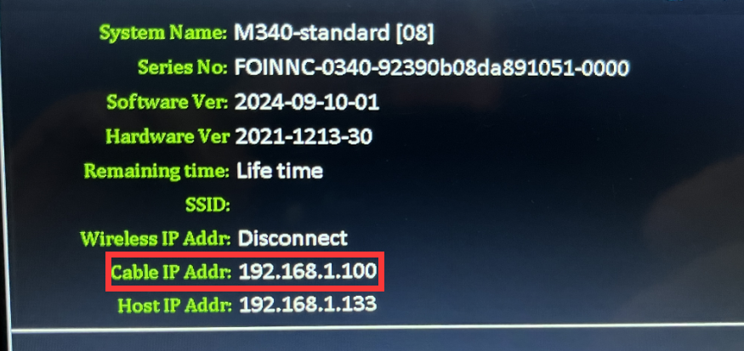
- Test whether the network connection between the computer and M350 is OK;
the method is as follows:
Access the command line interface on the computer and enter the following command, then press Enter: ping 192.168.1.100.
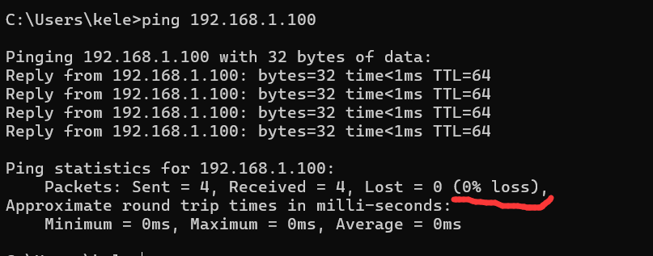
If the above prompt appears, it indicates that the network connection is normal.

- Set the remote host IP address for M350.
First, check the IP address on the computer side:
In the command line, type: ipconfig and press Enter.
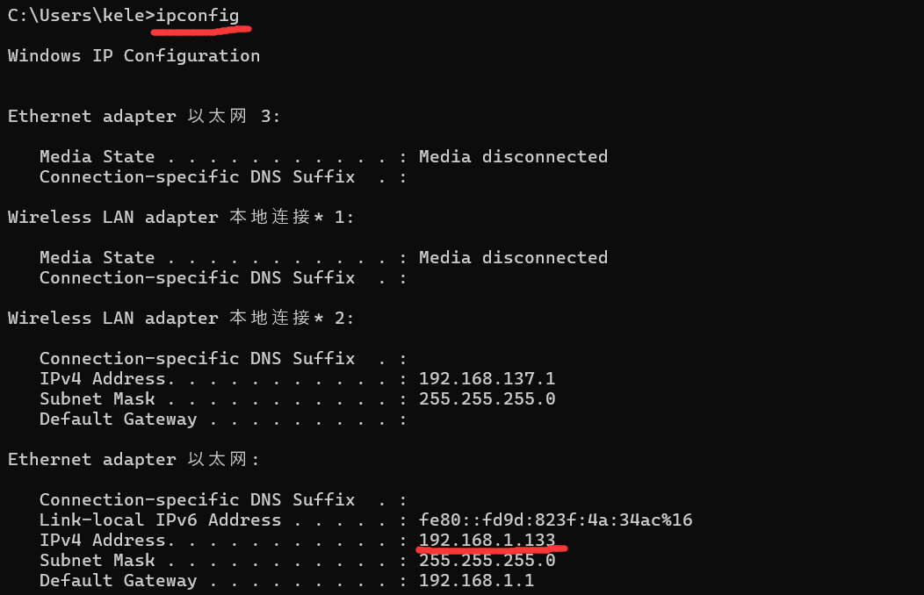
As shown in the image above, the computer's IP address is 192.168.1.133.
In the M350 system management interface, press F4 - System Set, and set the remote IP address as shown in the image below.
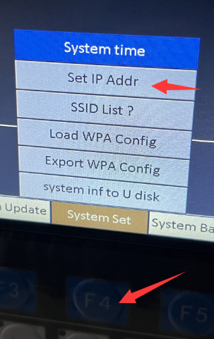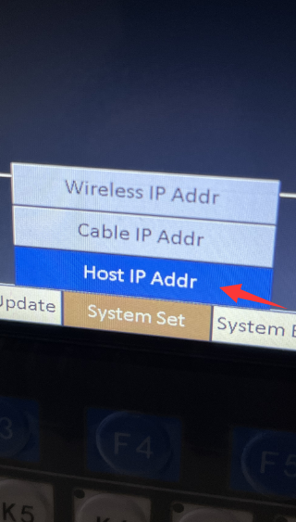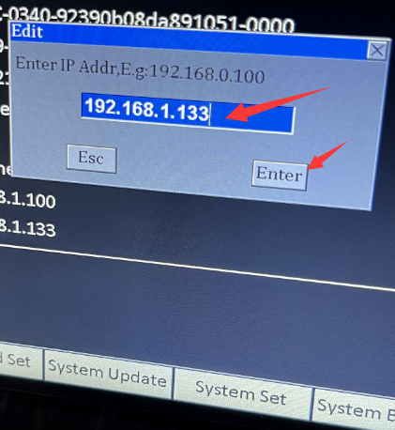
设置完成后如下如：
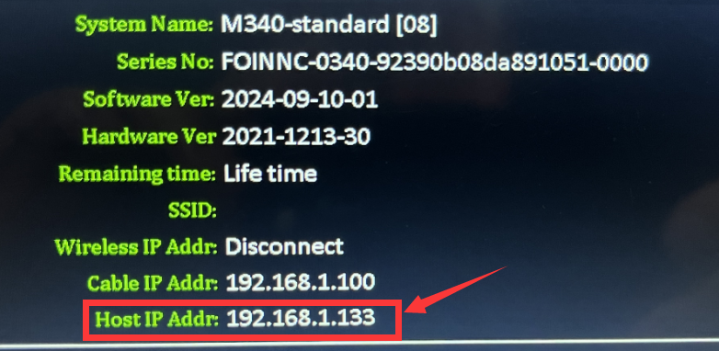

- Open the SMB service on the computer, as shown below:
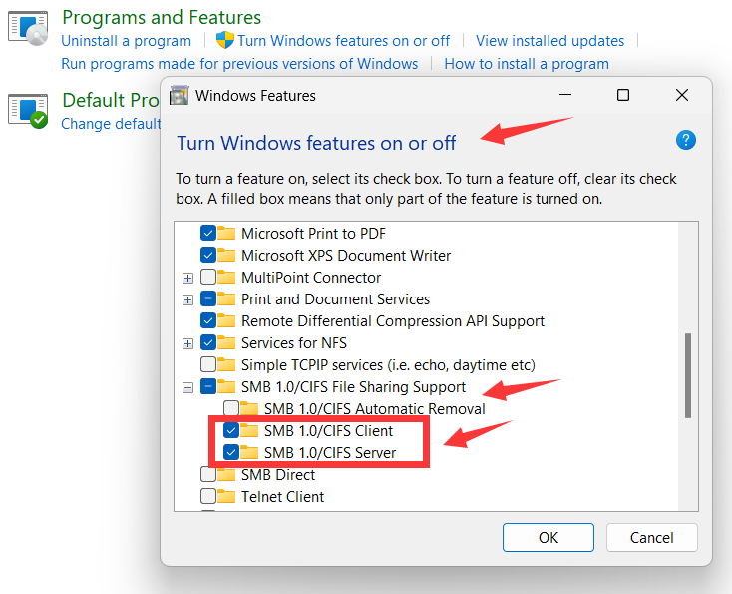
Restart the computer.
- Enter the advanced sharing settings interface and turn on the file sharing switch,
as shown in the image below:
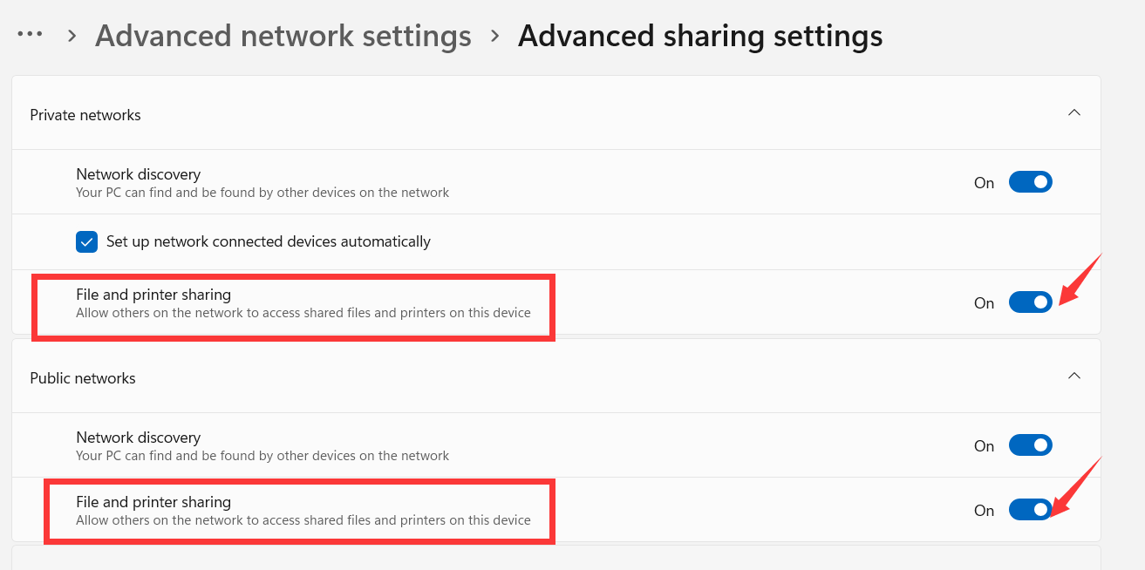

- Create a new shared folder using the following method:
Create a new folder in any location on the computer's disk, with any name. Then, right-click the folder, select 'Properties,' and go to the 'Sharing' tab as shown in the image below:
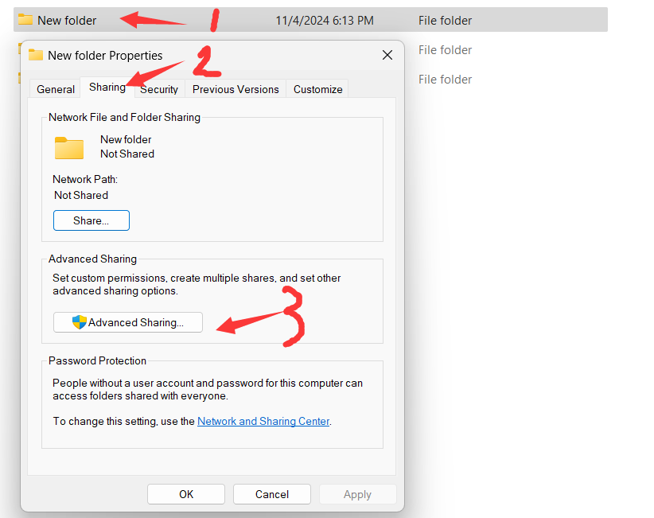
Select 'Advanced Sharing,' enter the share name, and confirm.
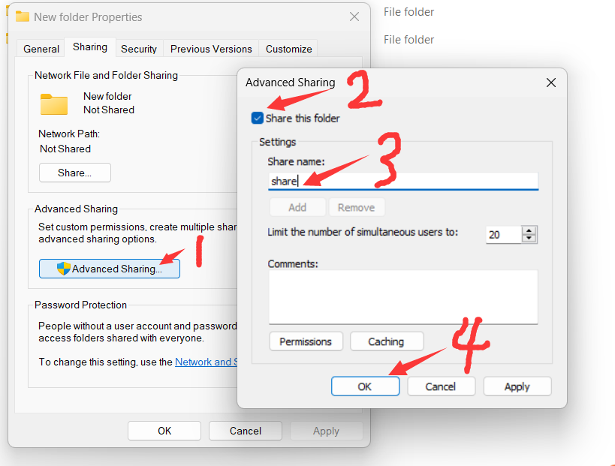
Share this folder: The default share name is 'share.' Note that this share name must match the #806 string in msg, msg1, and msg2: the factory default is #806 'share.'

Then follow the steps shown in the images one by one:
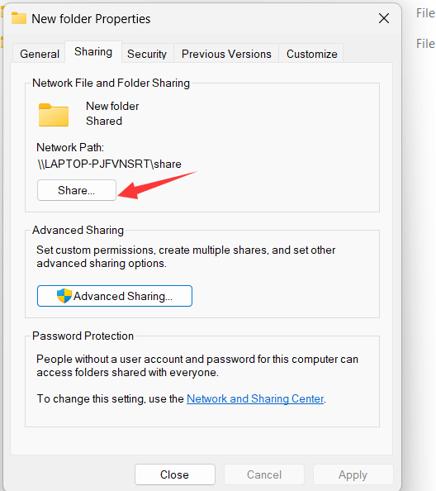
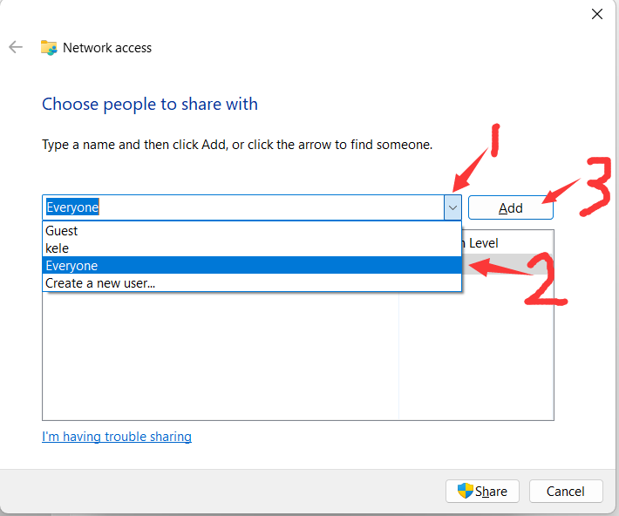
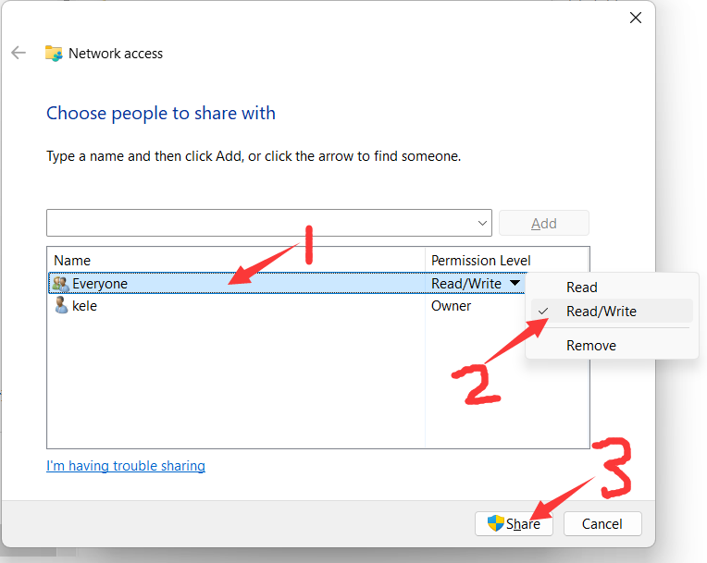
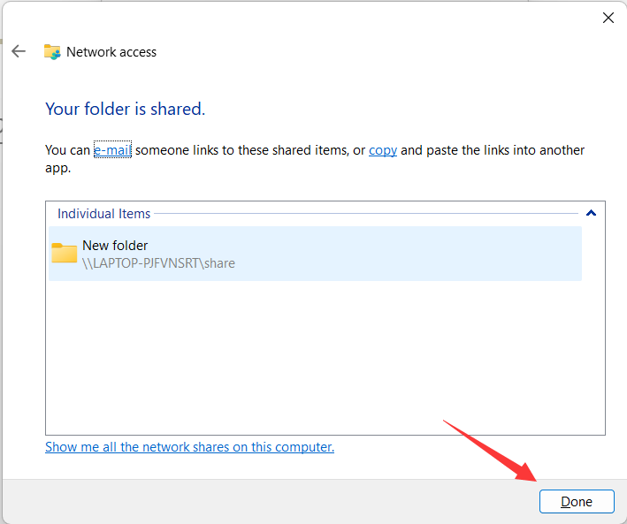
The folder sharing is complete!
- Test whether the M350 can remotely access the computer's files:
Place a test file in the shared folder:
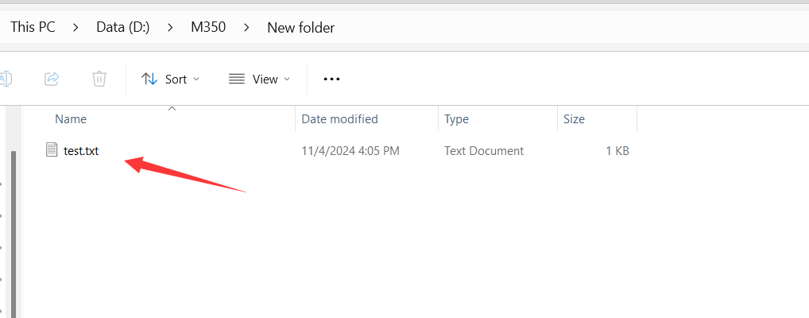
Enter the M350 interface and press F1 to switch disks, as shown in the image below:
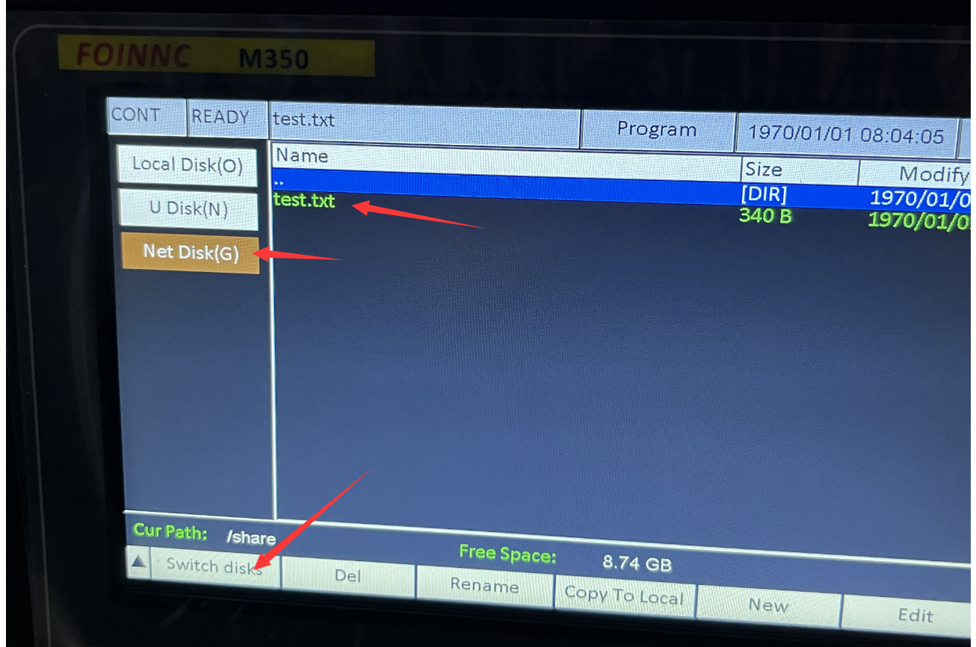
Note: If access is not successful after switching, please press the disk switch button one more time!
- Appendix
  - Update History
Version | Content | Release Date | Author
1.0 | Initial Release | 2024/11/04 | Q.G. Zhang

